Provision AWS VPC:

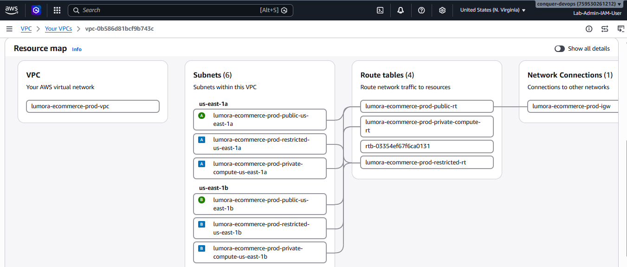

Configure Security Groups:

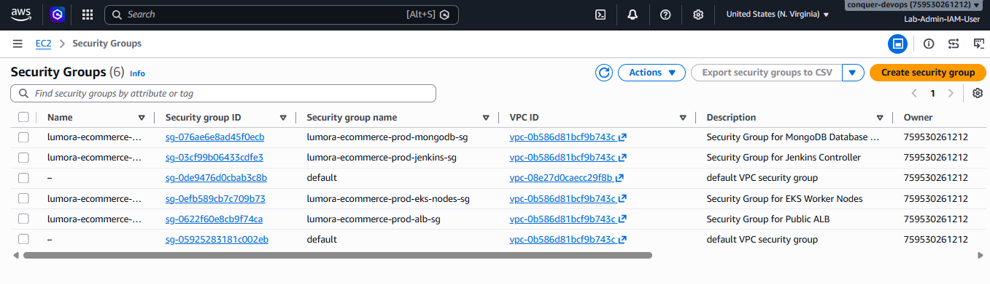

Povision EC2 server for Jenkins:
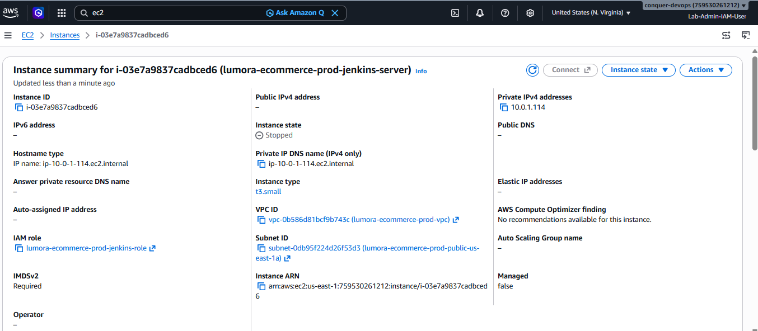

Create AWS ECR repository:

